Diagrams
Impact of model
Individual
Society
Environmental
Context - Phases
First Phase - Text cleaning
Second Phase - TF-IDF vectorisation
Third Phase - SBERT encoding
Fourth Phase - Assembling features to fit
Fifth Phase - Logistic Regression
Human behaviour
Negation and sarcasm
Writing style and slang
Language evolution
Bias in the model
Training data bias
Negativity bias
Label bias
Reslopify

Diagrams

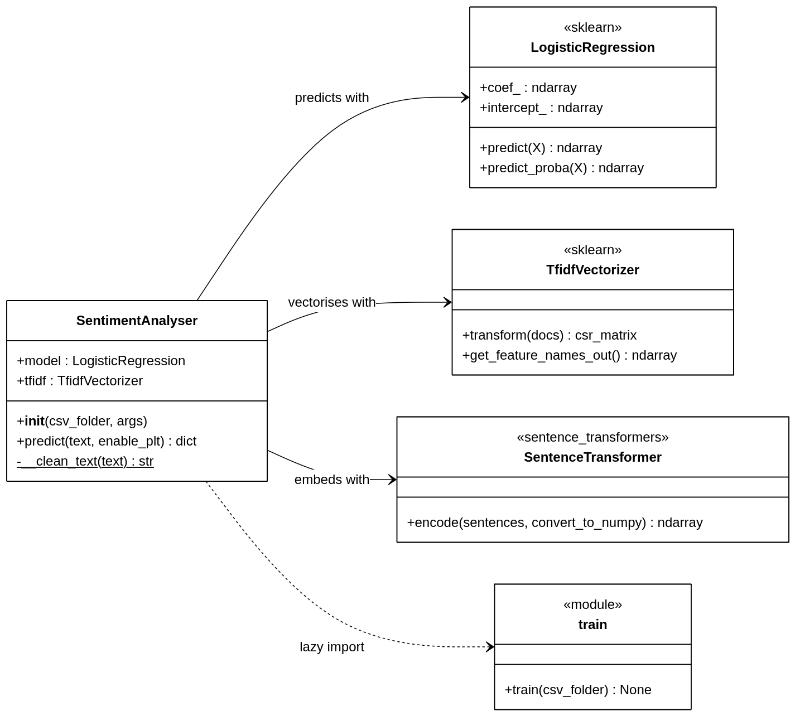

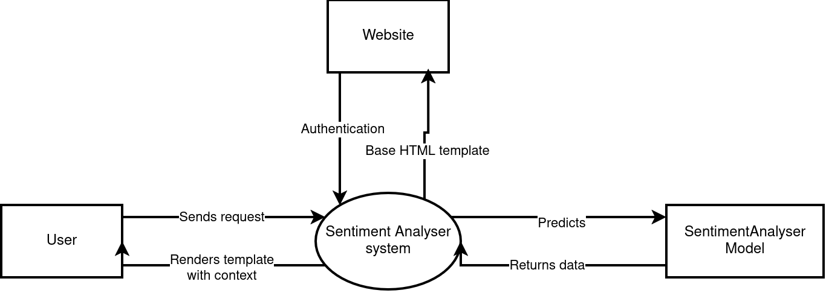

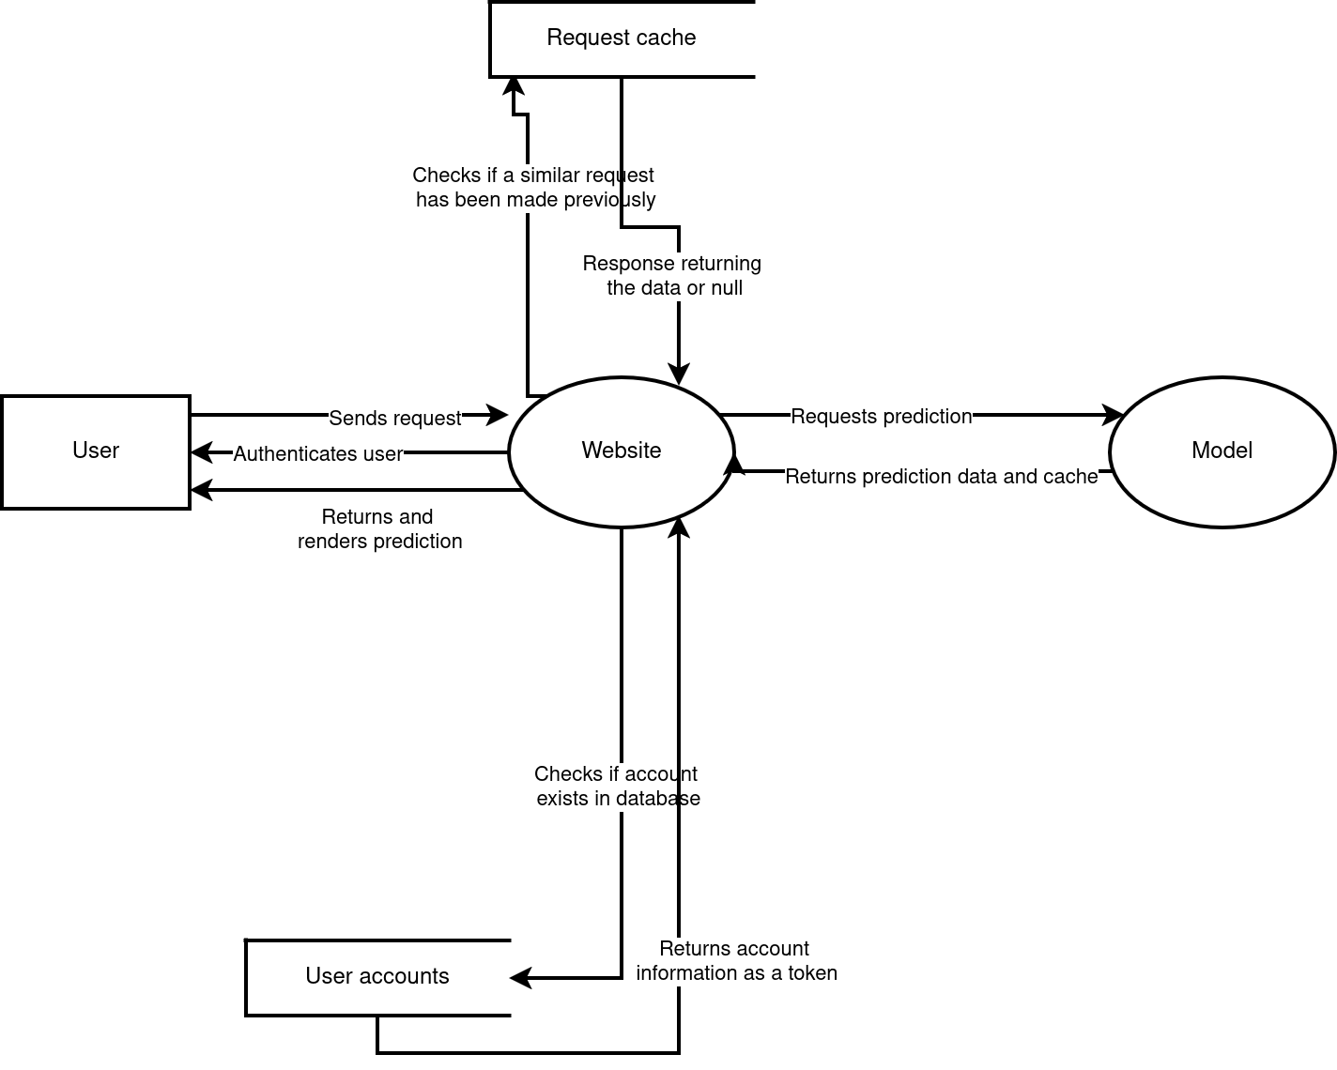

Impact of model

Individual
- The website hosting the model allows for token weight breakdowns to be available and makes the predictions justifiable.
- In pass 1, non-ascii characters are stripped, losing certain meaning. Multilingual users may receive incorrect answers quietly.
- The model’s dataset is more negatively skewed due to the dataset it is trained on, which could make the resulting data be more negative than it actually is.

Society
- When deployed at scale, miscalculations can have extremely bad consequences if perceived in a wrong way.
- The user feedback system provides more training data that can be re-fed into the model along with its current data set and helps to improve data quality and accuracy.
- No safeguard is available to flag any text being sent over. For example, if a suicidal person types in a method into the chatbox and it shows as positive, it may lead to the kill of a person. Human review is not possible.

Environmental
- “all-MiniLM-L6-v2” is a distilled, small transformer, significantly cheaper than full BERT-scale models while retaining semantic quality
- The checkpoint system during training allows for caching and removes redundant recompilation.
- SBERT having to be trained on 600,000 rows is GPU-intensive, with it taking 6 minutes to encode the entire training set.

Context - Phases
Note: I am adding context to use for references. If you are interested in how it predicts, read this, otherwise you can always just refer it back.

There are multiple phases to the prediction of text in this model:

First Phase - Text cleaning
To be able to accurately predict the model, it will clean up any unrelated text (such as non-ascii characters, urls, hashtags, html leftovers [cleaned up with flask-wtf]). It then expands out any contractions to allow for negation checking (don’t -> do not), then lastly lowercased for uniformity and stripped to convert into the token itself.

"This movie was NOT good!" -> ["this", "movie", "was", "not", "good"]

Second Phase - TF-IDF vectorisation
The cleaned string is then passed into the TF-IDF vectoriser. This pass is used to locate its weighting with the trained vocabulary to get a resultant weighting.

In this case, ["this", "movie", "was", "not", "good"] would be converted into a numpy type:

x_tfidf → (0, 8423) 0.3812 # "good"
(0, 19201) 0.4156 # "movie"
(0, 22847) 0.4931 # "not"
(0, 22901) 0.5634 # "not good"
(0, 39102) 0.2201 # "this"
(0, 44812) 0.1987 # "was"

If you might have noticed, there is a duplicate of “not”, “good” and then “not good”. The vectoriser is trained to capture any potential bigrams (pairs of words) and then determine its weighting. In this case, it is perceived “not good” to be a bigram because it uses a negator/contradiction paired with a word.
Weighting “not” + “good” gives a value of 0.4931 + 0.3812 = 0.874, while “not good” gives 0.5634. The “not” is supposed to be negative, however its importance is too high, so capturing bigrams are used.

["this", "movie", "was", "not", "good"] -> a bunch of features

Third Phase - SBERT encoding
SBERT is a pretrained neural network model that supports the weighting of TF-IDF vectorisation. Unlike TF-IDF, SBERT reads the words in order and understands the negation structurally. This encodes the semantic meaning of the sentence into each of the tokens.

Because the fact that “not good” is semantically similar to that of “bad” and “terrible”, its vector will sit close to those words.

"this movie was not good!"
↓
Transformer layers
↓
384-dim dense vector → truncated to first 128 dims

sbert_128 ≈ [-0.12, 0.34, -0.05, 0.41, -0.29, ...]

Fourth Phase - Assembling features to fit
This feature pulls both the TF-IDF weighting of the words and the SBERT encoding values and adds the two values together.
TF-IDF will contain mostly zeroes, as it checks for each word. With the amount of power and datasets, it would be impossible to get all the weightings of the words in the English language, therefore it will not be full of data.
On the other hand, SBERT will be non-zero and contain a lot of metadata. This was already explained previously (or if not adequately, google is always available).

x_features = [ tfidf_dim_0...tfidf_dim_N | sbert_dim_0...sbert_dim_127 ]
|___ Pass 2 output ___| |_____ Pass 3 output ______|
sparse, mostly zeros dense, all non-zero

Fifth Phase - Logistic Regression
Now for the part Mr Jones is excited about: Logistic Regression takes these features and combines both features and calculate the dot product of the vectors, then adding the intercept (the LogisticRegression previous training data, specifically the bias as mentioned in the equation y=wx+b where w is weighting and b is bias). Adding the three values creates a final logit (logistic function), which then gets passed into the sigmoid function.

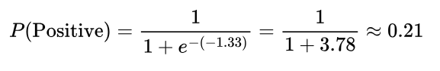
Since P(Positive) is 21%, P(Negative) has to be 79%. Therefore, the class is Negative with an accuracy/confidence of 79%. Try it out yourself if you don’t believe me…
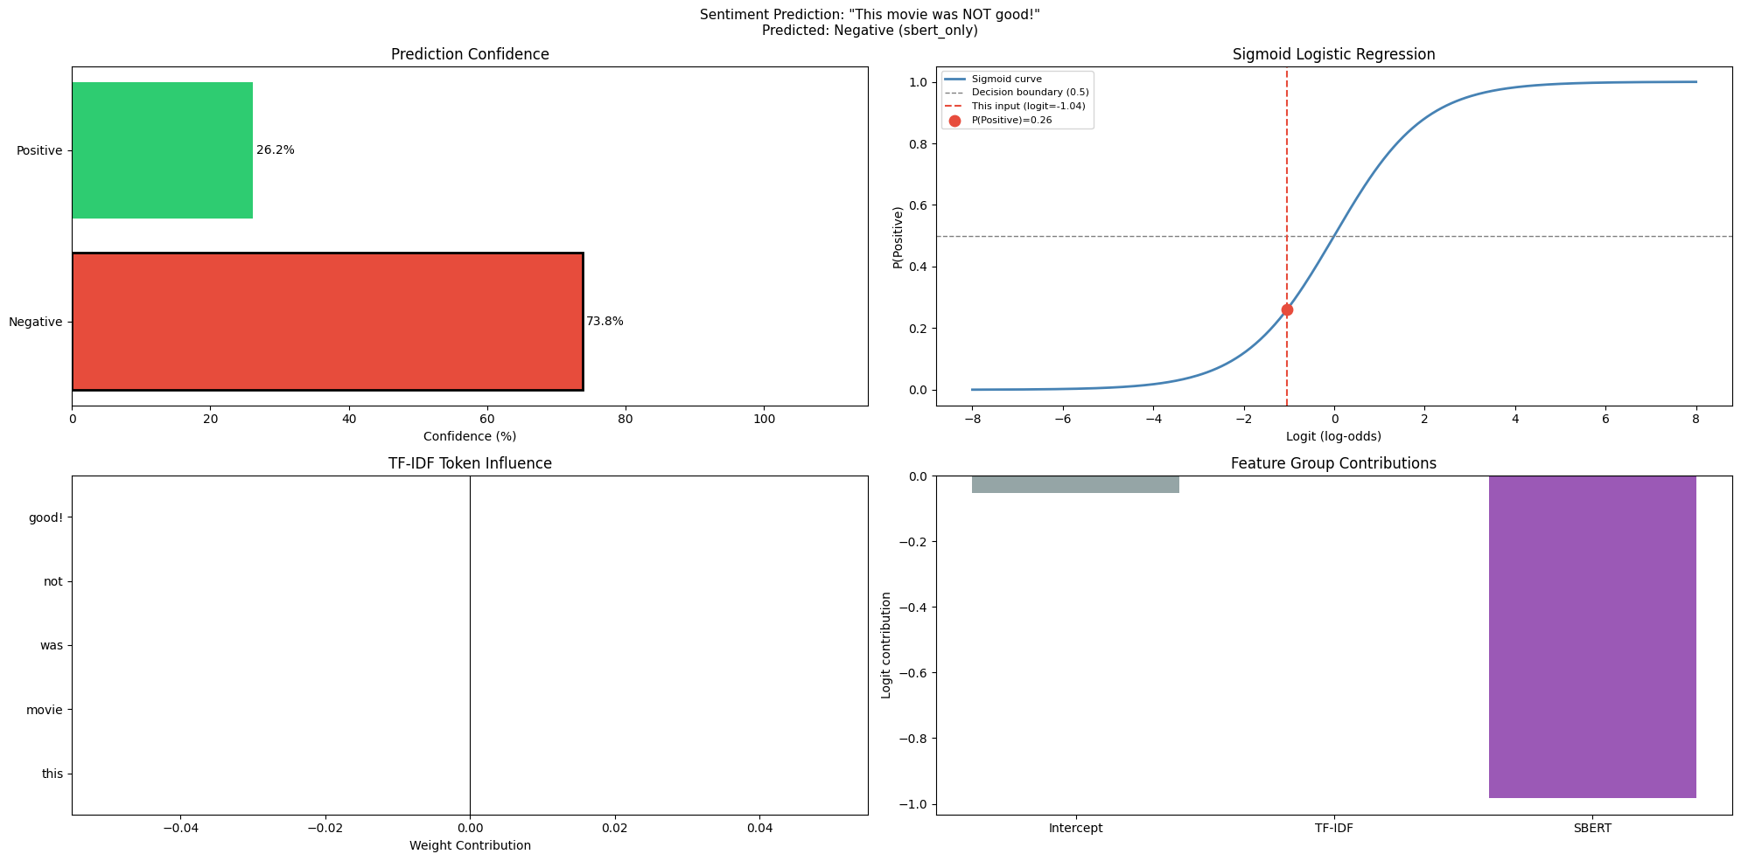

Human behaviour
Since a SentimentAnalysis model is a natural language processor, it converts words into numbers and determines the weighting from that.

Negation and sarcasm
One issue of humans is their use of sarcasm. Take this example:

“This is just GREAT, lost my data again 🙃”

The word ‘GREAT’ adds sarcasm to the sentence. A fluent English speaker would be able to understand this as sarcasm due to its usage, however the dictionary of TF-IDF does not recognise the sarcasm and instead regards this word as positive. SBERT would fix it up (partially, not guaranteed), however the bias originally set by TF-IDF will skew the sentence to a more positive sentiment. Neither Pass 2 and 3 have sarcasm detection, so the model's prediction depends entirely on whether the two logit corrections happen to overcome the misleading word signal.

Writing style and slang
Humans express language through alternative versions of words, such as intensity being defined as longer expressions of words (e.g. sooooooooo), using capital letters (e.g. I HATE THIS SO MUCH) or even using slang to define a different meaning of the same word (e.g. this girl is a baddie).

During phase 1, it will be cleaned so everything is normalised and lowercase, removing intensity markers.
The TF-IDF in Phase 2 may or may not (extremely low chance) recognise the word and its sentiment, so it will likely do no vocab and return a value of 0.0.
SBERT in phase 3 provides a backstop, because it's context-aware. Its effectiveness is capped to the first 128 dimensions discarding about 67% of the model's semantic capacity.

Language evolution
As the English language progresses and trends rise and fall, slang will rise and fall with it. The training cutoff will affect the slang recognition, and phase 2 will be severely affected, with words not existing in its dictionary being silently classified as 0.0.

Bias in the model

Training data bias
The datasets skew towards English-speaking western views, with a young population and predominantly first-person view. This is due to the datasets being chosen being sentiments from Twitter, which overrepresents these demographics. As a result, sentiment expressions typically stem from these views and those who type in text following these values will have more accurate ideas, and worse for those not in those demographics.

Negativity bias
As stated in the previous point, bias in the model is skewed to Negative. This is because of the history of twitter being a place to express feelings. By nature, the platform is used to speak out about complaints and share similar ideas. This produces more negative content in general compared to something like IMDB which would produce equally justified reviews.

During training, this bias is attempted to be cleaned up to the best of its abilities by splitting and discarding unbalanced data, however this only goes so far.

When in production, the model starts off the text in negative territory, and requires sufficient evidence to prove that it is positive.
For neutral or ambiguous inputs where neither TF-IDF nor SBERT produces a strong signal, the intercept alone tips the prediction to Negative.

Label bias
Using only positive and negative as the only classifiers removes the amount of potential classification available, removing other human emotions such as “fear”, “curiosity” or even “envy”. Of course, it would require more work to classify, however it does tighten the number of different classes to classify with.

Reslopify
The feedback model is used as a way to improve the model, however retraining the exact same dataset and trimming/correcting the values only regurgitates the training data. This leads to the model not being improved and essentially building on top of the same training data.

